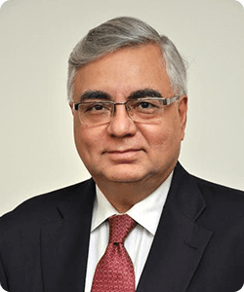

Dr. Parthasarathi Shome is Founder Chairman, International Tax Research and Analysis Foundation (ITRAF), Bengaluru, India (2017-present). He was Adviser (Level of Secretary/Minister of State) to the Indian Finance Minister (2004 -14), and chaired the Tax Administration Reform Commission (TARC) (2013-15). In between, he was Chief Economist, UK Revenue and Customs (2008-11). Before that, he was Chief of Tax Policy, IMF (1992-95); and Professor, American University, Washington DC. He chaired India’s Ninth and Tenth Five Year Plan Task Forces on tax policy and administration. He was Director of National Institute of Public Finance and Policy (NIPFP) (1995-97) and International Council for Research on International Economic Relations (ICRIER), New Delhi, India (1999-2001). He has published books and articles in academic journals. He participates regularly in international debate and discussions on international taxation and is invited to speak across the globe. He received Brazil’s highest civilian honour, Commander of the Order of the Southern Cross, for his contributions to Brazilian fiscal reform (2000). For details see https://parthoshome.com/

